

**Module Code & Module Title**

CS6PO5 Final Year Project

Digital ANFA

**Assessment Type**

Interim Report

**Year and Semester**

2019-20 Autumn

**Student Name:** Pranaya Pradhan **Internal Supervisor:** Rohit Pandey

**London Met ID:** 17030952 **External Supervisor:** Shekhar Timsina

**College ID:** np01cp4a170020

**Assignment Due Date:**

**Assignment Submission Date:**

**Word Count:**

*I confirm that I understand my coursework needs to be submitted online via Google Classroom under the relevant module page before the deadline for my assignment to be accepted and marked. I am fully aware that late submissions will be treated as non-submission and a mark of zero will be awarded.*

Table of Contents

1. Introduction 1

1.1. Introduction to Topic 1

1.2. Current Scenario 1

1.3. Problem Domain 1

1.4. Scope 1

1.5. Aims and Objectives 1

1.5.1. Aims 1

1.5.2. Objectives 1

2. Background 2

2.1. Project Elaboration 2

2.2. Terms/Definition 2

2.3. System Architecture 3

2.4. Feature 4

2.4.1. For Web (Admin/Editor) 4

2.4.2. For Mobile Application (User) 7

2.5. Wireframe 10

2.5.1. Wire Frame of Website 10

For Admin 11

For Editor 17

2.5.2. Wire Frame of Mobile Application 24

1. Use Case of Each Feature 29

For Web(Admin/Editor) 30

3.2.1. Use Case of News Feed 30

3.2.2. Use Case of Fixtures 32

3.2.3. Use Case of Club Detail 34

3.2.4. Use Case of Player Detail 36

3.2.5. Use Case of Statistics 38

For Mobile (User) 40

3.2.6. Use Case of News Feed 40

3.2.7. Use Case of Fixtures 41

3.2.8. Use Case of Statistics 42

3.2.9. Use Case of Club Profile 43

Table of Tables

Table 1 Keeps News in Feed 31

Table 2 Update the Fixtures 33

Table 3 Upload Club Detail 35

Table 4 Upload Player Detail 37

Table 5 Stores the Statistics 39

Table 6 Reads News in Feed 40

Table 7 Knows the Fixtures 41

Table 8 Use Case of Views Statistics 42

Table 9 Table of Views Stastistics 42

Table 10 Table of Gets Club and Player Detail 43

Table of Figure

Figure 1 System Architecture of Digital ANFA 2

Figure 2 Login 8

Figure 3 Register 8

Figure 4 Admin Dashboard to Add Editors 9

Figure 5 Admin Dashboard for News Feed 9

Figure 6 Admin Dashboard to Add News in News Table 10

Figure 7 Admin Dashboard for Club Detail 10

Figure 8 Admin Dashboard to Add Club Detail 11

Figure 9 Admin Dashboard for Player Profile 11

Figure 10 Admin Dashboard to Add Player Detail 12

Figure 11 Admin Dashboard for Fixtures 12

Figure 12 Admin Dashboard to Add Highest Scorer 13

Figure 13 Admin Dashboard to Add Red Card 13

Figure 14 Admin Dashboard to Add Yellow Card 14

Figure 15 Editor Dashboard for News Feed 15

Figure 16 Editor Dashboard to Add News in News Feed Table 15

Figure 17 Editor Dashboard for Club Detail 16

Figure 18 Editor Dashboard to Add Club Detail 16

Figure 19 Editor Dashboard for Player Detail 17

Figure 20 Editor Dashboard to add Player Detail 17

Figure 21 Editor Dashboard for Fixtures 18

Figure 22 Editor Dashboard to Add Fixtures 18

Figure 23 Editor Dashboard for Highest Scorer 19

Figure 24 Editor Dashboard to Add Highest Scorer 19

Figure 25 Editor Dashboard for Yellow Card 20

Figure 26 Editor Dashboard to Add Yellow Card 20

Figure 27 Editor Dashboard for Red Card 21

Figure 28 Editor Dashboard to Add Red Card 21

Figure 29 Splash Screen 22

Figure 30 News Feed Section 23

Figure 31 Fixture Section 24

Figure 32 Statistics Section 25

Figure 33 Profile Section 25

Figure 34 About Us Section 26

Figure 35 Overall Use Case 27

Figure 36 Adds News 28

Figure 37 Edit News 28

Figure 38 Delete the News 29

Figure 39 Add Fixtures 30

Figure 40 Edit the fixtures 30

Figure 41 Delete the Fixture 31

Figure 42 Add Club Detail 32

Figure 43 Edit Club Detail 32

Figure 44 Delete Club Detail 33

Figure 45 Use Case of Add Player Detail 34

Figure 46 Use Case of Delete Player Detail 35

Figure 47 Add Statistics 36

Figure 48 Edit Statistics 36

Figure 49 Delete Statistics 37

Figure 50 Use Case of News Feed 38

Figure 51 Use Case of Fixtures 39

Figure 52 Use Case of Club Profile 41

Figure 53 ERD Diagram 43

# Introduction

## Introduction to Topic

## Current Scenario

## Problem Domain

## Scope

## Aims and Objectives

### 1.5.1. Aims

The main aim of this project is to build a football statistics mobile application for the Football Association which displays the information about the Qatar Memorial A Division League organized by the FA where data are updated by the admin or the editor in website.

### 1.5.2. Objectives

The following are the objectives of the projects:

1. To develop a user-friendly and simple website and mobile application
2. To make a deep research on various sources such as books, journal, reports, the whitepaper, etc. in order to complete the project on time.
3. To develop mobile applications.
4. To fulfil all the requirement of the client.
5. To select and use proper tools for developing the project.
6. To handle the testing of the project.
7. To provide proper document and user documentation about the project to the client.

To develop an error-free mobile application and website

# Background

## Project Elaboration

## Terms/Definition

## System Architecture

The following diagram represents the system architecture of the project:

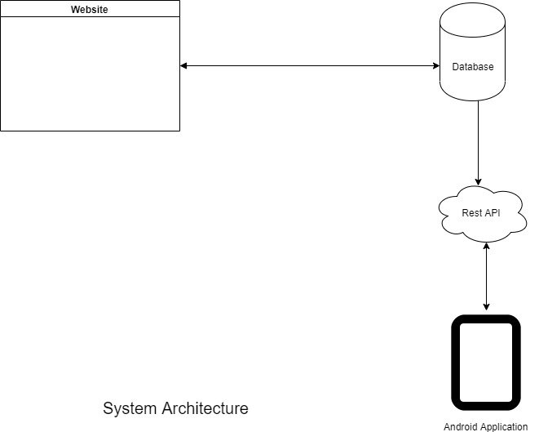

Figure 1 System Architecture of Digital ANFA

## Feature

### 2.4.1. For Web (Admin/Editor)

* Admin
* User
  + - Username
    - First Name
    - Last Name
    - Email
    - User Password
    - Actions:
      * Add the Editor
      * Update the Editor detail
      * Delete the Editor (if required)
* Admin and Editor
* News Feeds
* News Title
* News Type
* News Description
* News Image
* Date
* Actions:
  + Add the News
  + Update the News
  + Delete the News (if required)
* Club Detail
* Club Name
* Club Description
* Club Founded Date
* Club Address
* Club Email
* Club Division
* Club Affiliation
* Home Jersey Colour
* Away Jersey Colour
* Club Sponsor
* Kit Sponsor
* Club Logo
* Actions:

- Adds the Club details

- Update/Edit the Club details

- Delete the Club detail (if required)

* Player Detail
* First Name
* Last Name
* Date of Birth
* Place of Birth
* Gender
* Position
* Country
* Image
* Club Id
* Status (active/inactive)
* Actions:
  + Adds the Player details
  + Update/Edit the Players details
  + Delete the Player details (if required)
* Tournaments
  + - Tournament Id
    - Tournament Name
    - Tournament Type
    - Season
    - Title Sponsor
    - Organizers
    - Actions:
  + Adds the tournaments detail
  + Edit/Update the tournaments detail
  + Delete the tournaments detail
* Fixtures/Match
* Club 1
* Club 2
* Date
* Kick Off Time
* Venue
* Club 1 Score
* Club 2 Score
* Club 1 Result
* Club 2 Result
* Status (Played/Not Yet Played)
* Actions:
* Adds the match/fixtures detail
* Edit/Update the fixture detail
* Delete the fixture detail
* Statistics
* Highest Scorer
  + Player Id
  + Player First Name
  + Player Last Name
  + Club
  + Total Goals
* Red Card
  + Id
  + Player Name
  + Club
  + Total Cards
* Yellow Card
  + Id
  + Player Name
  + Club
  + Total Cards
* Clean Sheets
  + Id
  + Player Name
  + Club
  + Total Number of Clean Sheets
* Actions:
* Adds the Statistics detail
* Edit/Update the Statistics Detail
* Delete the Statistics Detail

### 2.4.2. For Mobile Application (User)

* News Feeds
* News Title
* News Description
* News Type
* News Image
* Date
* Actions:
  + Views the news feeds
* Club Detail
* Club Name
* Club Description
* Club Logo
* Club Address
* Club Email
* Club Telephone
* Club Affiliation
* Actions:

- Views the Club Detail

* Player Detail
* Player Name
* Date of Birth
* Place of Birth
* Position
* Jersey No
* Nationality
* Image
* Club Id
* Status (activate/deactivate)
* Actions:
  + Views the Player Detail

* Fixtures
* Club 1
* Club 2
* Date
* Time
* Venue
* Result
* Actions:
* Views the Fixtures
* Statistics
* Views Points Table
* Highest Scorer
  + Id
  + Player Name
  + Club
  + Total Goals
* Red Card
  + Id
  + Player Name
  + Club
  + Total Cards
* Yellow Card
  + Id
  + Player Name
  + Club
  + Total Cards
* Actions:
* Views the Statistics

## Wireframe

### 2.5.1. Wire Frame of Website

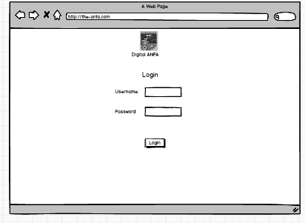

Figure 2 Login

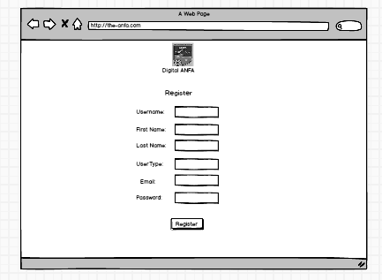

Figure 3 Register

### For Admin

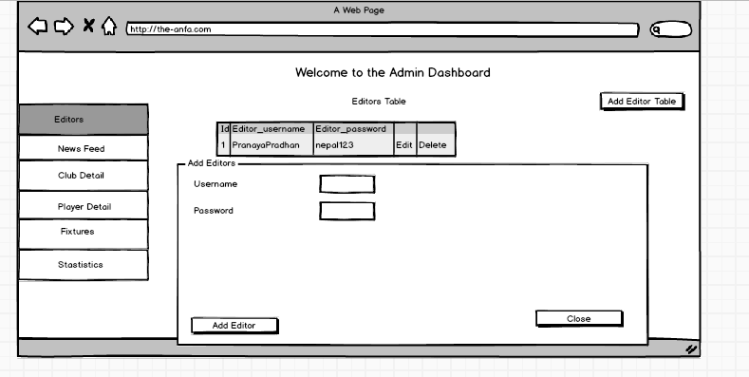

Figure 4 Admin Dashboard to Add Editors

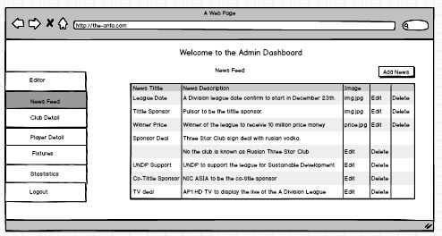

Figure 5 Admin Dashboard for News Feed

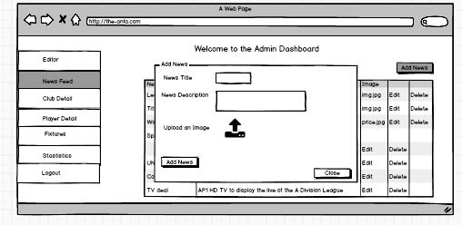

Figure 6 Admin Dashboard to Add News in News Table

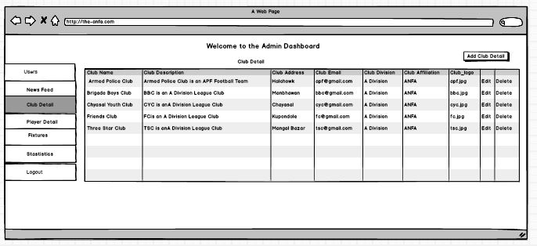

Figure 7 Admin Dashboard for Club Detail

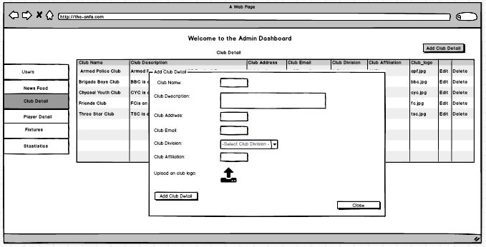

Figure 8 Admin Dashboard to Add Club Detail

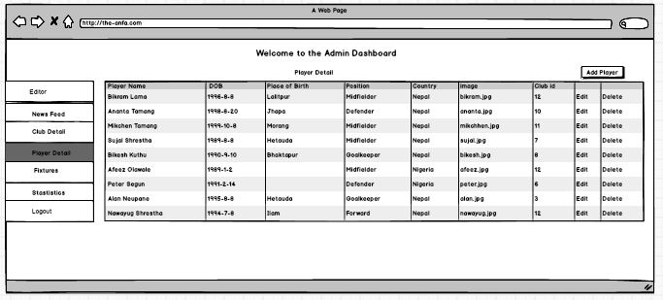

Figure 9 Admin Dashboard for Player Profile

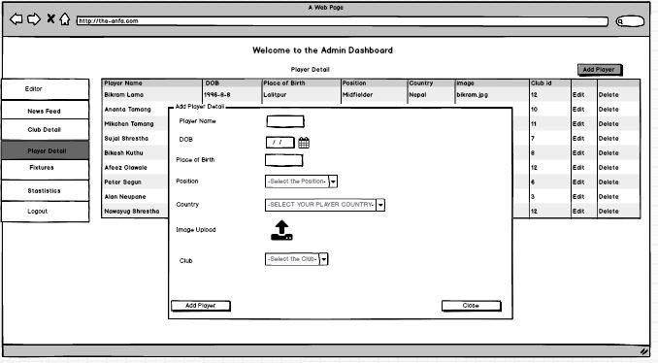

Figure 10 Admin Dashboard to Add Player Detail

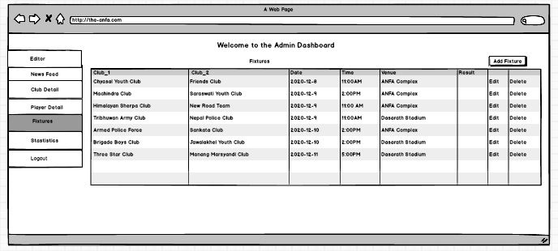

Figure 11 Admin Dashboard for Fixtures

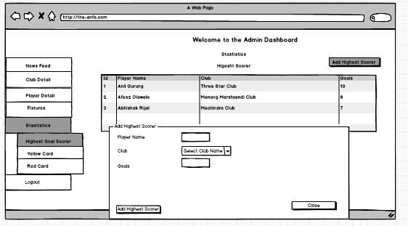

Figure 12 Admin Dashboard to Add Highest Scorer

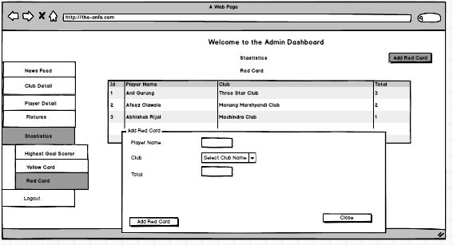

Figure 13 Admin Dashboard to Add Red Card

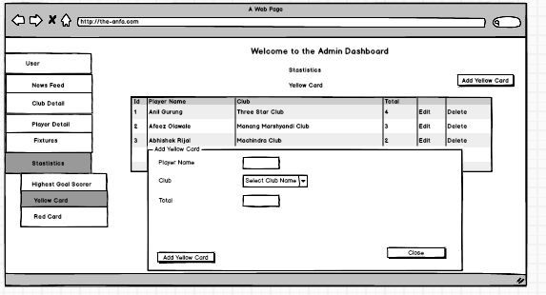

Figure 14 Admin Dashboard to Add Yellow Card

### For Editor

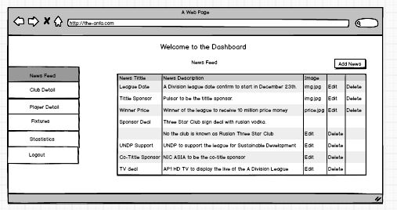

Figure 15 Editor Dashboard for News Feed

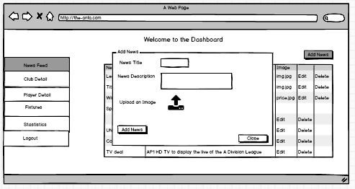

Figure 16 Editor Dashboard to Add News in News Feed Table

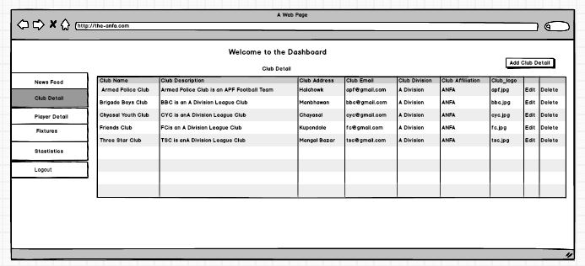

Figure 17 Editor Dashboard for Club Detail

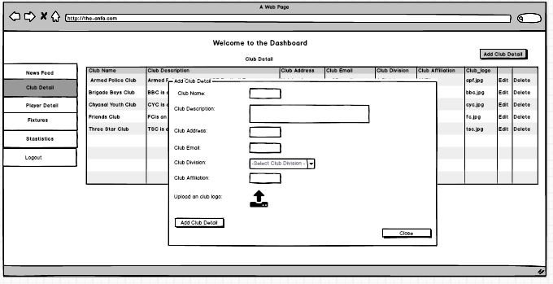

Figure 18 Editor Dashboard to Add Club Detail

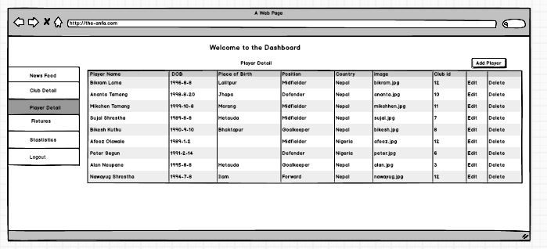

Figure 19 Editor Dashboard for Player Detail

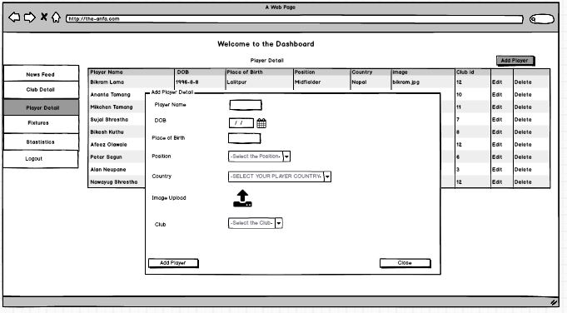

Figure 20 Editor Dashboard to add Player Detail

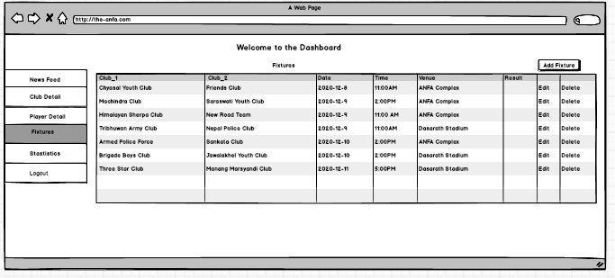

Figure 21 Editor Dashboard for Fixtures

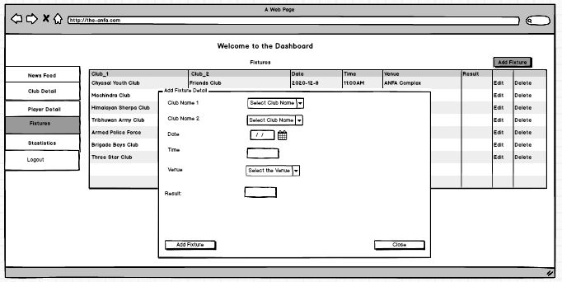

Figure 22 Editor Dashboard to Add Fixtures

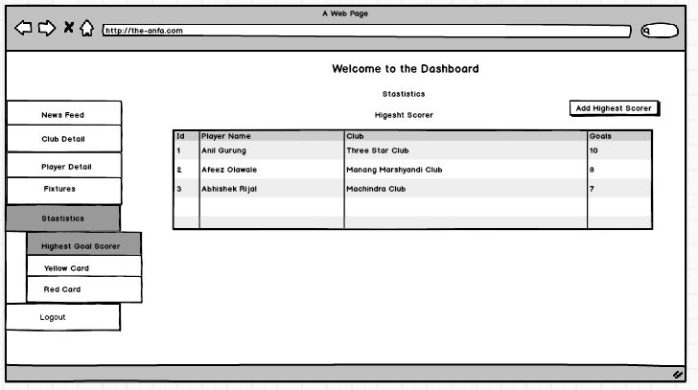

Figure 23 Editor Dashboard for Highest Scorer

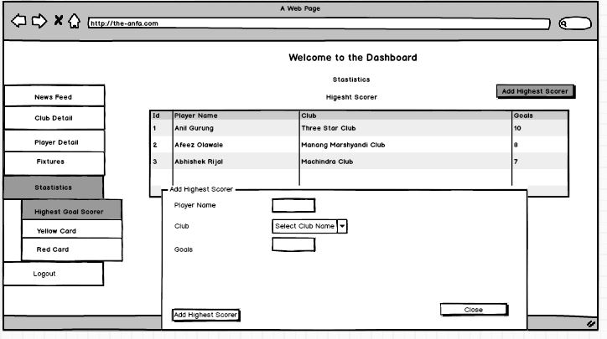

Figure 24 Editor Dashboard to Add Highest Scorer

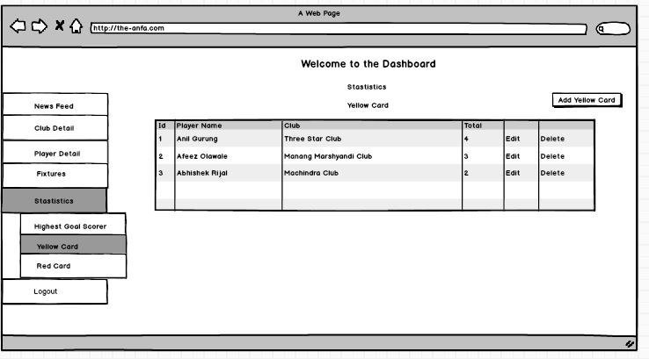

Figure 25 Editor Dashboard for Yellow Card

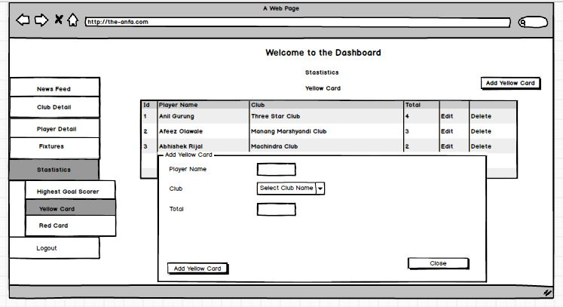

Figure 26 Editor Dashboard to Add Yellow Card

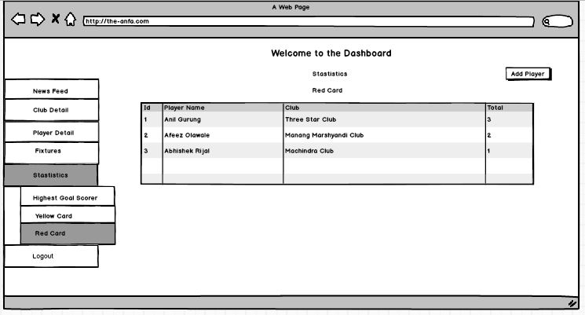

Figure 27 Editor Dashboard for Red Card

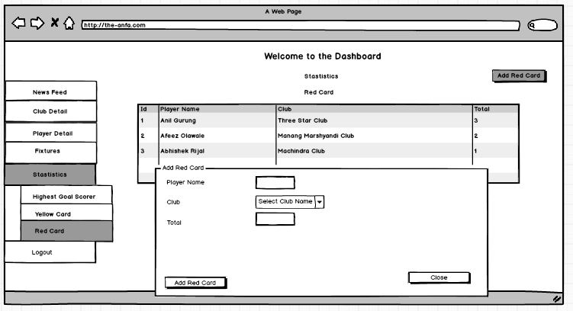

Figure 28 Editor Dashboard to Add Red Card

### 2**.5.2. Wire Frame of Mobile Application**

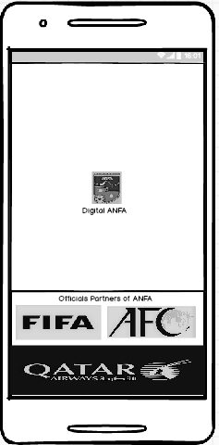

Figure 29 Splash Screen

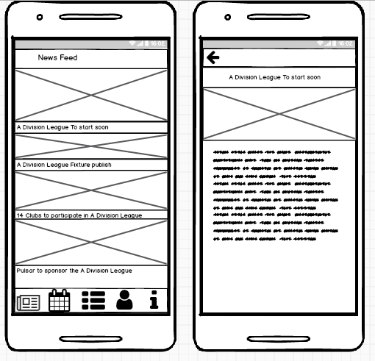

Figure 30 News Feed Section

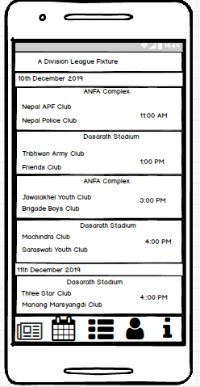

Figure 31 Fixture Section

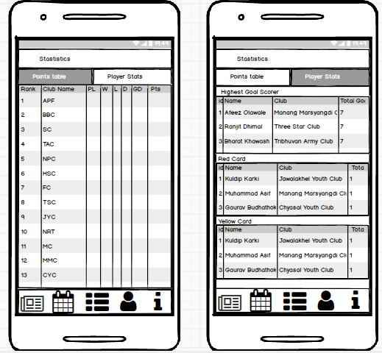

Figure 32 Statistics Section

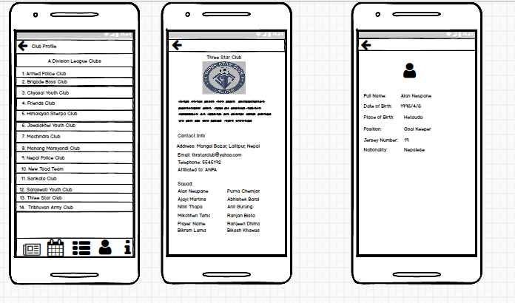

Figure 33 Profile Section

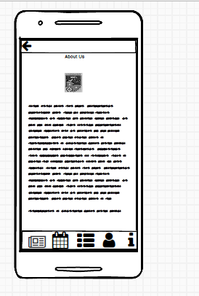

Figure 34 About Us Section

# Use Case of Each Feature



Figure 35 Overall Use Case

### For Web(Admin/Editor)

### Use Case of News Feed



Figure 36 Adds News



Figure 37 Edit News



Figure 38 Delete the News

|  |  |
| --- | --- |
| Name: | Keeps News in Feed |
| Actors: | Editor, Admin |
| Description: | The actors keep the news in the news feed section. He/she can add, edit and delete the news. |

Table 1 Keeps News in Feed

### Use Case of Fixtures



Figure 39 Add Fixtures



Figure 40 Edit the fixtures



Figure 41 Delete the Fixture

|  |  |
| --- | --- |
| Name: | Update the fixtures |
| Actors: | Editor, Admin |
| Description: | The actors have permission to update the fixture of the matches. |

Table 2 Update the Fixtures

### Use Case of Club Detail



Figure 42 Add Club Detail



Figure 43 Edit Club Detail



Figure 44 Delete Club Detail

|  |  |
| --- | --- |
| Name: | Upload Club Detail |
| Actors: | Editor, Admin |
| Description: | The actors have right to upload the club detail. Similarly, he/she can edit as well delete the detail if require. |

Table 3 Upload Club Detail

### Use Case of Player Detail



Figure 45 Use Case of Add Player Detail



Figure 42 Use Case of Edit Player Detail



Figure 46 Use Case of Delete Player Detail

|  |  |
| --- | --- |
| Name: | Upload Player Detail |
| Actors: | Editor, Admin |
| Description: | The actors have right to upload the player detail. Similarly, he/she can edit as well delete the detail if require. |

Table 4 Upload Player Detail

### Use Case of Statistics



Figure 47 Add Statistics



Figure 48 Edit Statistics



Figure 49 Delete Statistics

|  |  |
| --- | --- |
| Name: | Stores the Statistics |
| Actors: | Editor, Admin |
| Description: | The actors have an ability to record the statistics of the matches. |

Table 5 Stores the Statistics

### For Mobile (User)

### 3.2.6. Use Case of News Feed



Figure 50 Use Case of News Feed

|  |  |
| --- | --- |
| Name: | Reads the News in Feed |
| Actors: | User |
| Description: | The actors view the news tittle and images as well as can read the news. |

Table 6 Reads News in Feed

### 3.2.7. Use Case of Fixtures



Figure 51 Use Case of Fixtures

|  |  |
| --- | --- |
| Name: | Knows the Fixtures |
| Actors: | User |
| Description: | The actors can know the fixture of the match of tournament. |

Table 7 Knows the Fixtures

### 3.2.8. Use Case of Statistics



Table 8 Use Case of Views Statistics

|  |  |
| --- | --- |
| Name: | Views Statistics |
| Actors: | User |
| Description: | The actors have right to statistics of the match. |

Table 9 Table of Views Stastistics

### 3.2.9. Use Case of Club Profile



Figure 52 Use Case of Club Profile

|  |  |
| --- | --- |
| Name: | Gets Club and Player Detail |
| Actors: | User |
| Description: | The actors gets the detail of the clubs and players. |

Table 10 Table of Gets Club and Player Detail